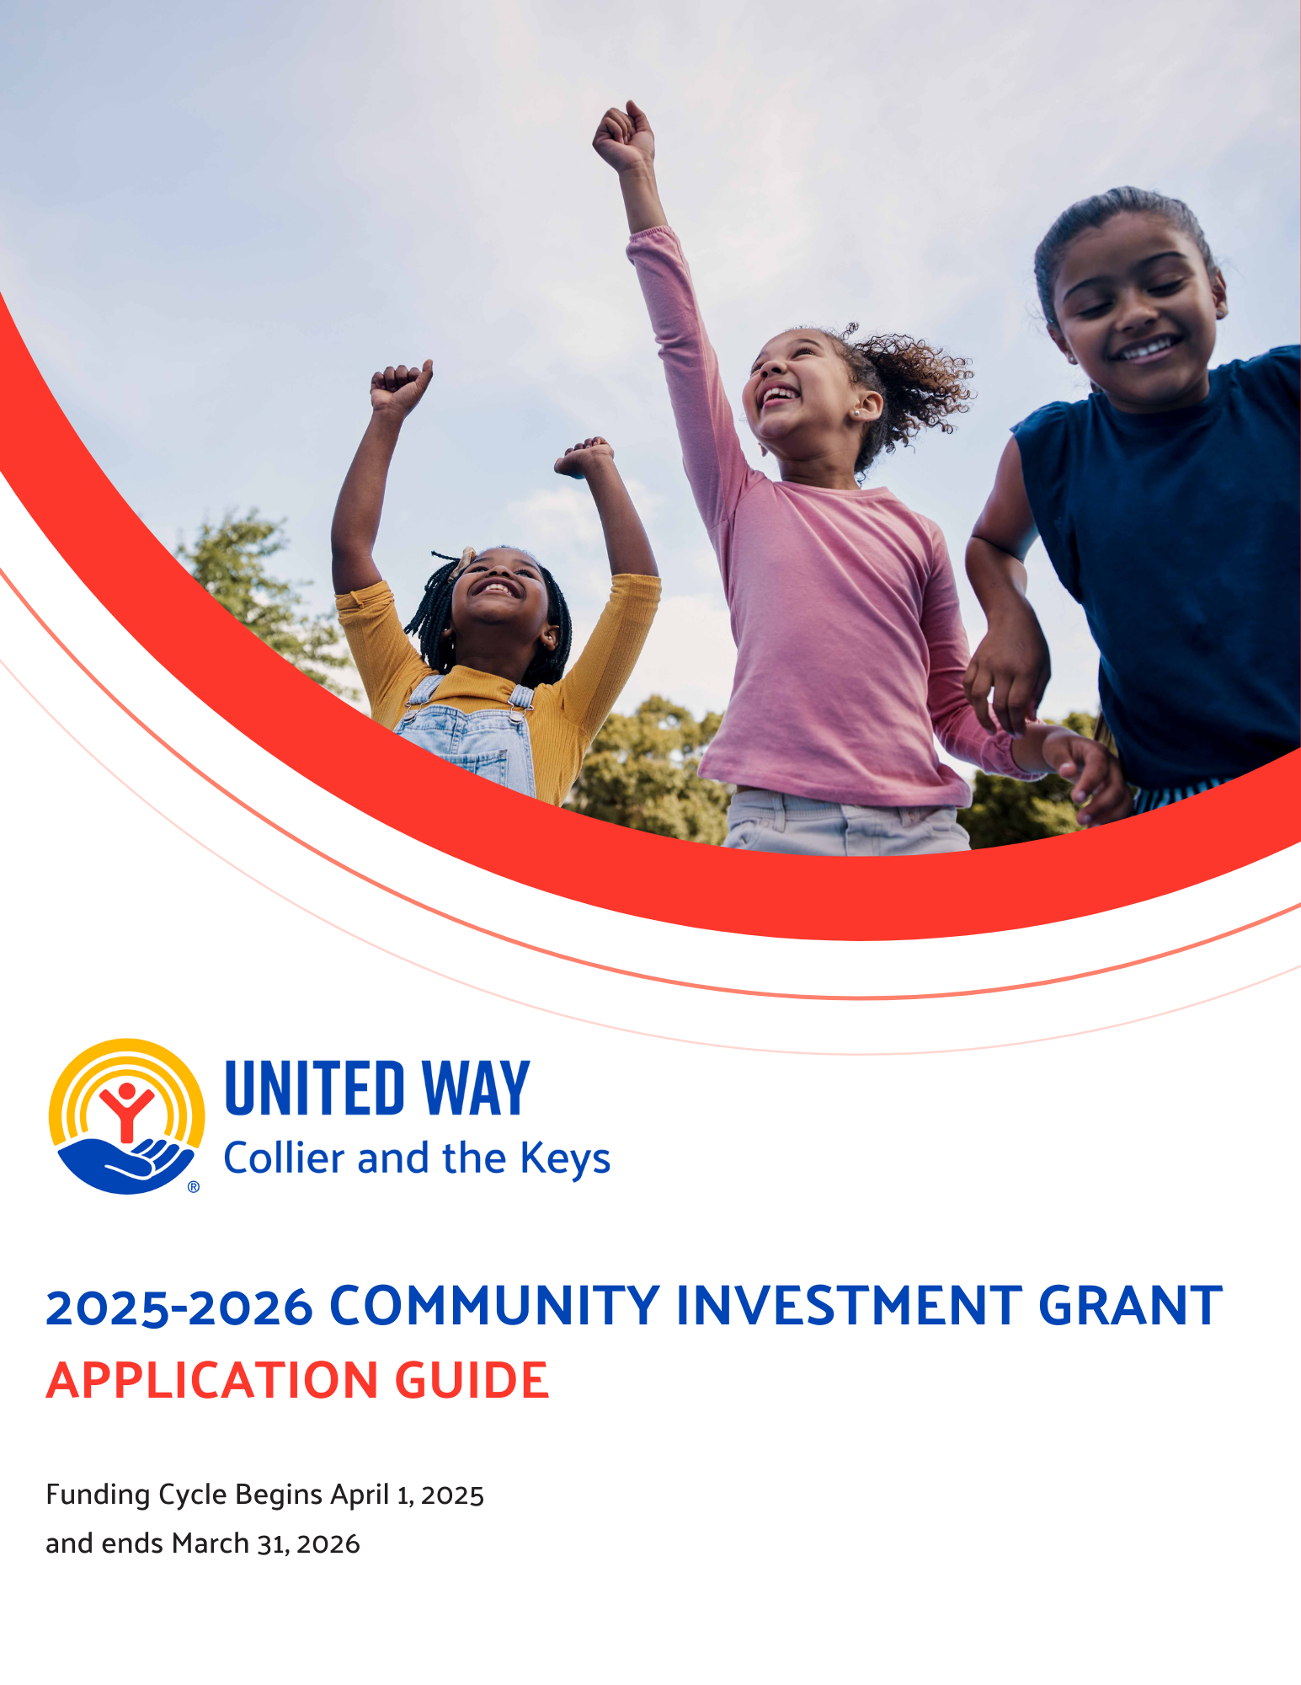

# 

# UWCK 2025-26 Community Investment Grant

**Request for Proposals**

Thank you for your interest in partnering with United Way of Collier and the Keys (UWCK) to support our Collier and Monroe County communities in 2025-26. This guide is intended to provide instruction and guidance for our annual Community Investment Grant process. It includes requirements on eligibility, programmatic focus, and reporting, as well as essential background information. Please review this document in its entirety before requesting access to the application (available beginning Wednesday, December 4, 2024).

**About United Way of Collier and the Keys:**

Our missionis to improve lives by mobilizing the caring power of community to advance the common good. From strengthening local resilience to advancing health, youth opportunity, and financial security, UWCK is mobilizing communities to action so all our neighbors can reach their full potential.

**Our Goals and Why We Fund:**

UWCK stands as a convener, collaborator, and catalyst for transformative change. Our vision is bold: to ensure that all individuals living and working in Collier County and the Florida Keys have the essential resources and opportunities to truly thrive. Through strategic partnerships, intentional dialogue, and focused grant funding, UWCK supports our community members who are Asset Limited, Income Constrained, and Employed (ALICE). These are households that, despite earning above the Federal Poverty Level, still struggle daily to meet their basic needs. ALICE includes the very people who form the foundation of our community and our economy—teachers, first responders, nurses, childcare providers, retail workers, nonprofit employees, restaurant and hotel staff, and so many more.

For ALICE families, a single unexpected event—a car repair, a natural disaster, a medical expense—can trigger a cascade into economic instability, a cycle that’s tough to break. Suddenly, everyday decisions become impossible choices: pay the rent or buy groceries, seek medical care or cover childcare costs, pay the electric bill or fuel the car. The short-term sacrifices ALICE households are forced to make have lasting repercussions that impact not only their futures but also the overall health and success of our community. We recognize that the future stability of Collier County and the Florida Keys relies on the financial resilience of ALICE households.

UWCK’s Community Investment Grants play a pivotal role by directing donor contributions into local programs that empower and equip ALICE families to transition from crisis to stability and, ultimately, to thriving. Through these targeted investments, we aim to foster a stronger, more resilient community where everyone has the chance to build a secure and sustainable future.

**Who Should Apply for Funding:**

UWCK is seeking applications from nonprofit agencies to receive funding for programs in our identified impact areas of **Community Resiliency, Financial Security, Healthy Community, and Youth Opportunity.**

The 2025-26 UWCK Community Investment Grant application is a competitive and transparent process open to qualified agencies meeting eligibility criteria. The following requirements must be met to apply for a Community Investment Grant:

* Agency must be a 501(c)(3) organization.
* All documents listed under the header “Required Documents” can be provided.
* Program serves Collier County or Monroe County.
* Program drives meaningful change for the ALICE population, empowering them to transition from surviving to thriving.
* Agency acts in accordance with a written non-discrimination policy outlining that it operates without discrimination in hiring, service delivery, or volunteer services based on race, religion, gender, sexual orientation, national origin, age, or disability.
* Program addresses at least one of UWCK’s impact areas below; competitive applications will offer a program that addresses at **least one initiative in the corresponding impact areas:**

|  |  |
| --- | --- |
| **IMPACT AREA** | **INITIATIVE** |
| **Community Resiliency**  Addressing urgent needs today for a better tomorrow | 1. Disaster Response and Recovery  2. Crisis Hotline and Support  3. Emergency Preparedness  4. Environmental Stewardship and Sustainability |
| **Financial Security**  Creating a stronger financial future for every generation | 1. Adult Education, Job Training, and Career Pathways  2. Financial Education and Empowerment  3. Legal Support  4. Homelessness Prevention   1. Shelter, Affordable Housing, and Home Ownership 2. Access to Public Benefits 3. Emergency Financial Assistance (Rent, Utilities, and Other Critical Needs) |
| **Healthy Community**  Improving health and wellbeing for all | 1. Healthcare Access  2. Healthy Spaces and Physical Activity  3. Health Education  4. Nutrition and Food Security |
| **Youth Opportunity**  Helping young people realize their full potential | 1. Childcare and Early Childhood Education  2. In-School, After-School, and Summer Programs  3. Literacy Development  4. College/Career Readiness |

**How to Apply**:

All applications and supporting documentation will be submitted through UWCK’s online portal. No emailed or mailed submissions will be accepted. Currently funded agencies or agencies who previously applied or were funded can apply with existing login credentials to the [online grant portal](https://agency.e-cimpact.com/login.aspx?org=11190F). New agencies interested in applying can request login credentials through the [online grant portal](https://agency.e-cimpact.com/login.aspx?org=11190F) by creating a new e-CImpact account. UWCK staff must approve new account requests in e-CImpact before an agency can gain access to the application, so please plan accordingly.

## Key Dates:

Funded agencies are expected to keep track of all submission dates; failure to meet a deadline may affect current or future funding. The FY25-26 grant cycle will begin on Monday, April 1, 2025, and end on Monday, March 31, 2026.

|  |  |
| --- | --- |
| December 4, 2024 | FY25-26 Community Investment Grant application opens by 11:59 PM EST |
| January 8, 2025 | FY25-26 Community Investment Grant application closes at 11:59 PM EST |
| February 5, 2025 | Questions submitted to applicants on behalf of volunteers by 5:00 PM EST |
| February 7, 2025 | Answers to questions due from applicants, if applicable, by 11:59 PM EST |
| March 21, 2025 | Applicants notified of funding decisions |
| March 24, 2025 | Awarded agencies receive MOUs |
| March 28, 2025 | MOUs completed and returned by 5:00 PM EST |
| April 1, 2025 | FY25-26 Community Investment Grant cycle begins |
| October 15, 2025 | Interim Report due 11:59 PM EST |
| March 31, 2026 | FY25-26 Community Investment Grant cycle ends |
| April 15, 2026 | Final Report due by 11:59 PM EST |

## Required Documents:

Incomplete applications, or ones without all required documents outlined below, will be automatically denied consideration for funding. Required documents include:

* A copy of your agency’s IRS determination letter.
* Annual audited financials, review, or compilation [per state statute](http://www.leg.state.fl.us/statutes/index.cfm?App_mode=Display_Statute&Search_String=&URL=0400-0499/0496/Sections/0496.407.html) (496.407).
  + A typed statement on official letterhead regarding your agency’s exemption from a required audit, review, or compilation must be uploaded if exempt.
* A copy of your agency’s most recent CPA Management Letter.
  + A typed statement on official letterhead regarding your agency’s exemption from a required audit, review, or compilation must be uploaded if exempt.
* A copy of your most recent IRS 990 or 990EZ.
  + For agencies not required to file a 990 or 990EZ, per [IRS requirements](https://www.irs.gov/charities-non-profits/form-990-series-which-forms-do-exempt-organizations-file-filing-phase-in), audited financials may be accepted.
  + A typed statement on official letterhead regarding your agency’s exemption from filing a 990 or 990EZ must be uploaded if exempt.
* Most recently completed agency balance sheet no older than June 2024.
* Most recently completed income statement (profit and loss) no older than June 2024.
* The current fiscal year agency budget.
* A copy of your agency’s most recent Annual Report for the Florida Department of State Division of Corporations (sunbiz.org).
* A copy of your agency’s State Solicitation of Contributions registration (DOACS).
* A full roster of your board of directors.
* A copy of your agency’s non-discrimination policy that outlines how it does not discriminate in hiring, service delivery, or volunteer services based on race, religion, gender, sexual orientation, national origin, age, or disability.

## Scoring Process and Awards:

Community Investment Volunteers will thoroughly review each application, evaluating programs based on established criteria. Should questions or clarifications be necessary, UWCK staff will liaise directly with the respective agencies to address these inquiries. Reviewers or UWCK staff may request further information during site visits or subsequent reviews to ensure a comprehensive evaluation. Agencies will be given a three-business-day window to respond to any additional information requests to maintain their application status. After completing the evaluations, our Community Investment Volunteers will make funding recommendations for their respective counties, which will then be submitted to the UWCK Board of Directors for final approval.

Awards are determined through a comprehensive review process focused on strategically maximizing positive impact within the community.

**Partnership Requirements:**

**Program Standards**

* UWCK values programs that avoid duplication, promote collaboration, make effective use of funds, and prioritize serving the ALICE population. Additionally, the agency should identify a specific tool or system to track and demonstrate measurable impact.
* The agency may apply for only one program associated with UWCK’s identified impact areas.
* UWCK requires all applicants to select and report on at least two outcome indicators over the funded grant cycle. These outcome indicators should align with the specific metrics associated with your chosen Impact Area. See Exhibit A for reference.
* The agency commits to using UWCK funds exclusively for the specified program as outlined in the application. Any substantial changes to the program’s scope, design, or delivery methods must be submitted in writing for UWCK’s review and approval.
* The agency will submit interim and final reports in October 2025 and April 2026. UWCK reserves the right to request a refund of any funds not applied toward the program, objectives, and activities outlined in the application.
* The grant contact person, along with any individual signing the application (if different), will respond promptly to UWCK communications and be available to discuss the funded program's progress.
* Grant proposals should demonstrate a strong commitment to advancing diversity, equity, and inclusion, prioritizing initiatives that break down systemic barriers and actively promote access, resources, and opportunities for all. Programs funded under these standards are expected to address community needs with inclusivity at their core, ensuring every individual can thrive, regardless of background or circumstance.
* The agency acknowledges that funding is designated for specific programs and initiatives that demonstrate clear results. This funding supports both direct and indirect (management and general) expenses related to delivering the program or initiative. Funding is not meant for capital expenses, lobbying efforts, fundraising events and/or to cover general deficits.

**Agency Reporting Requirements**

The combined impact of UWCK and our funded partner agencies far exceeds what any single one of us could achieve alone. Stakeholders are increasingly focused on the transformative power of collaboration among local agencies to drive meaningful change in our community. By uniting efforts, UWCK and our partners can effectively measure, amplify, and communicate our collective value.

**Our aim is to champion programs that are *connective*—bringing people and resources together, *responsive*—adapting to emerging needs, and *scalable*—expanding impact over time.**

Applicants should be prepared to submit bi-annual reports that include, but are not limited to, the following:

* **Total number of unduplicated individuals served** within the program listed in the agency’s application.
* **Outcome indicators** as outlined in the agency’s application and aligned with the selected impact area.
* **Total number of program volunteers** and the hours they contributed.
* **Client demographics** for the specified program, including:
  + Income level, aggregated based on current FPL to identify/track ALICE impact
  + Employment status
  + Age
  + Gender
  + Race/ethnicity
  + Target geographic areas served
* **Financial overview** detailing fund utilization and allocation.
* **Impact stories and relevant photos** that highlight the program's influence on clients and the community.

**Summary of the Community Investment Grant Process:**

**Wednesday, December 4, 2024 – Application opens at 8:00 AM EST**

Currently funded (FY24-25) agencies and agencies who have previously applied or been funded can apply with existing login credentials to the [online grant portal](https://agency.e-cimpact.com/login.aspx?org=11190F). New agencies interested in applying must request login credentials through the [online grant portal](https://agency.e-cimpact.com/login.aspx?org=11190F) by creating a new e-CImpact account. UWCK staff must approve new account requests in e-CImpact before an agency can gain access to the application, so please plan accordingly.

**Wednesday, January 8, 2025 – Application closes at 11:59 PM EST**

Late or incomplete submissions will not be considered for funding.

**Wednesday, February 5, 2025 – Questions submitted to applicants at 8:00 AM EST**

The Volunteer Committees will review applications and submit questions to UWCK staff to be addressed with individual agencies regarding their applications. Agencies will have three (3) business days to respond to questions.

**Friday, February 7, 2025 – Answers due from applicants by 11:59 PM EST**

Applicants are expected to respond promptly and thoroughly to inquiries by this deadline to avoid jeopardizing application status.

**Friday, March 21, 2025 – Applicants notified of funding decisions**  
Final decisions are made by the UWCK Board of Directors with recommendations from the Volunteer Committees from Collier and Monroe and will be relayed to agencies via email.

**Monday, March 24, 2025** **– Awarded agencies receive MOUs**

Awarded agencies receive FY 25-26 Community Investment Grant MOUs.

**Friday, March 28, 2025 – MOUs completed and returned by 5 PM EST**   
Awarded agencies must complete their respective MOUs and provide banking information.

**Tuesday, April 1, 2025** **– FY25-26 Community Investment Grant cycle begins**  
Awarded agencies are paid in monthly installments beginning April 2025.

**Wednesday, October 15, 2025 – Interim report due by 11:59 PM EST**  
Awarded agencies will report quantitative and qualitative results achieved with UWCK funding and progress made toward program objective(s) specified in their applications. This report will cover the period from April 1, 2025 to September 30, 2025.

**Tuesday, March 31, 2026 – Community Investment Grant cycle FY25-26 ends**

All UWCK grant funds must be expended by this date.

**Wednesday, April 15, 2026 – Final report due by 11:59 PM EST**  
Funded agencies will report quantitative and qualitative results achieved with UWCK funding and progress made toward program objectives specified in their applications. This report will cover the period from October 1, 2025 to March 31, 2026.

**Communication:**

Questions and clarifications about the Community Investment Grant process are welcome and should be directed in writing.

**For technical questions about the e-CImpact grant portal**, contact Rebecca Zehr, Grant Specialist, at [Rebecca.Zehr@uwcollierkeys.org](mailto:Rebecca.Zehr@uwcollierkeys.org). (Kindly note Rebecca’s hours are part-time, and an immediate response is not guaranteed. Please plan accordingly.)

**For programmatic questions**, contact Tiffany Pellicier, Director of Community Impact, at [Tiffany.Pellicier@uwcollierkeys.org](mailto:Tiffany.Pellicier@uwcollierkeys.org).

**COMMUNITY RESILIENCY**

* # of businesses and organizations implementing disaster preparedness plans
* # of community members participating in emergency preparedness training
* # of community partnerships created to promote green workforce opportunities
* # of homes that are “climatized” or prepared to withstand increases in climate change and climate-related weather events (such as wind, fire, floods, extreme heat, sea level rise, etc.)
* # of hours dedicated to skill-building in green or sustainable industries
* # of households that return to a stable housing situation within six months post-disaster
* # of individuals adversely impacted by a crisis or disaster that received emergency assistance (medical treatment, mortgage/rent/utility payments, transportation, legal services, etc.)
* # of individuals adversely impacted by a crisis or disaster that regained stability (reliable transportation, permanent housing, employment, etc.)
* # of individuals connected with necessary support services (mental health, shelter, financial assistance, etc.)
* # of individuals trained in environmentally sustainable job skills (e.g., renewable energy, conservation, marine biology)
* # of individuals who completed certifications in environmental fields (e.g., wildlife management, environmental engineering)
* # of individuals who receive mentorship from environmental professionals
* # of local agencies, businesses, and residents involved in preparedness partnerships
* # of participants in programs addressing the impact of climate change on the local economy and jobs
* # of youth involved in environmental internships or apprenticeships
* # or % of crisis responders trained in trauma-informed care
* % decrease in repeat calls/visits from individuals who receive support
* % decrease in time required to mobilize emergency response teams
* % of households with emergency kits and disaster plans in place
* % of individuals receiving follow-up support within 24 hours
* % of individuals reporting improved preparedness to withstand and recover from a disaster
* % of individuals reporting reduced distress after support is received
* % of individuals who gain employment in environmentally focused jobs post-training
* % of participants reporting increased knowledge of emergency preparedness plans
* % of program participants who remain in local, environmentally focused employment after one year
* % of students demonstrating increased understanding of ecosystems, climate, or environmental science after educational programs

**FINANCIAL SECURITY:**

* # of individuals no longer experiencing homelessness
* # of individuals served who gained employment
* # of individuals who accessed financial services, products, and/or education
* # of individuals who accessed more affordable housing
* # of individuals who increased their disposable income by accessing benefits or financial services/products allowing them to reduce costs
* # of individuals who maintained their jobs or wages
* # of individuals who received childcare assistance
* # of individuals who received emergency support services (rent/mortgage, utility, food, medical/healthcare, etc.)
* # of individuals who received housing-related services
* # of individuals who received literacy and writing support
* # of individuals who received other safety net-related services
* # of individuals who received transportation assistance to workplaces or social service providers
* # of individuals who stopped or reduced debt collection activity or received assistance with bankruptcy proceedings
* # of parents/caregivers who can continue working
* % of ALICE family caregivers who retain employment or increase work hours as a result of support for their dependent(s)
* % of ALICE family households who experience reduced out-of-pocket caregiving expenses due to external support services
* % of caregivers who report increased ability to balance employment, education, or personal responsibilities with caregiving
* % of individuals who earned job-relevant licenses, certificates, and/or credentials
* % of individuals who gained employment or secured better employment (part-time to full-time, benefits, salary/wage increase, etc.)
* % of individuals who maintained housing
* % of individuals with homeowner/tenant satisfaction

**HEALTHY COMMUNITY:**

* # of ALICE caregivers provided with training in caregiving skills
* # of ALICE families provided with respite services through care for seniors, individuals with disabilities, or other dependents
* # of grocery bags provided
* # of individuals assessed for eating healthier, increasing their physical activity, and/or enrolled in healthy food access/nutrition programs
* # of individuals assessed for health, wellness, identified risky behaviors, and/or improvement in their quality of life
* # of individuals assisted with enrollment in food assistance programs (such as SNAP, WIC, etc.)
* # of individuals assisted with enrollment in medical insurance (CHIP, Medicaid, Medicare, etc.)
* # of individuals directed to resources for healthy food or are provided nutrition education
* # of individuals provided with nutritional food, supplements, and/or supplies
* # of individuals served on a sliding scale fee
* # of individuals served without insurance
* # of individuals transported to healthcare appointments
* # of individuals who acquired immediate safety for themselves and/or their children
* # of meals provided
* % of ALICE families reporting reduced stress and improved quality of life due to respite care services
* % of individuals receiving treatment based on provided screenings or tests
* % of individuals who acquire skills/knowledge needed to progress their well-being (well-balanced diet, mental health, physical activity, etc.)
* % of individuals who gained knowledge of how to access/produce/preserve healthy foods

**YOUTH OPPORTUNITY:**

* # of children (birth to age 5) assessed for developmental milestones
* # of children (birth to age 5) enrolled in high-quality early childhood programs
* # of children (K-3) assessed for their reading level
* # of children (K-3) receiving literacy support
* # of families/caregivers provided with tools, information, resources, training, and/or teaching skills
* # of hours of literacy support provided to children (K-12)
* # of hours of support provided to children/youth
* # of youth (ages 5-18) assessed for increased skills in reading and writing in English
* # of youth (ages 5-18) who participate in in-school, out-of-school, and/or summer programs, and/or receive individualized support
* # of youth (ages 5-18) with increased skills in reading and writing in English
* # of youth who earned job-relevant licenses, certificates, and/or credentials
* # of youth who receive job skills training or experience
* # of youth who received their GED
* % of children (ages 0-5) who achieved developmental milestones
* % of children (K-3) reading at grade level
* % of children who maintain satisfactory or improved school performance
* % of middle/high school youth who earn passing grades in core subject areas
* % of youth who gain post-secondary employment, further education, or other credentials
* % of youth who gained employment
* % of youth who graduated high school on time
* % of youth who maintain satisfactory or improved attendance in school or at a place of employment
* % of youth who transition from middle to high school on time