FOR IMMEDIATE RELEASE: November 18, 2024
CONTACT: Alissa Hudak – Alissa.Hudak@uwcollierkeys.org

United Way of Collier and the Keys Unveils New Brand and Volunteer Hub

United is the Way! That’s the new tagline for United Way, introduced as part of a global brand refresh. On Thursday, November 14th, United Way of Collier and the Keys (UWCK) brought the excitement to life at its Community Impact Breakfast at Gulfshore Playhouse, unveiling its new logo, colors, and a strengthened commitment to the community.

This renewed brand strategy aims to spur greater engagement and action among the public, reinforcing what United Way stands for, and why people should get involved. At the heart of the revitalized brand are four impact areas: youth opportunity, healthy community, financial security, and community resiliency. UWCK is honored to be featured under United Way’s community resiliency realm for its reef revitalization work, while continuing to support ALICE (Asset Limited, Income Constrained, Employed) community members—those who make difficult decisions every day to make ends meet.

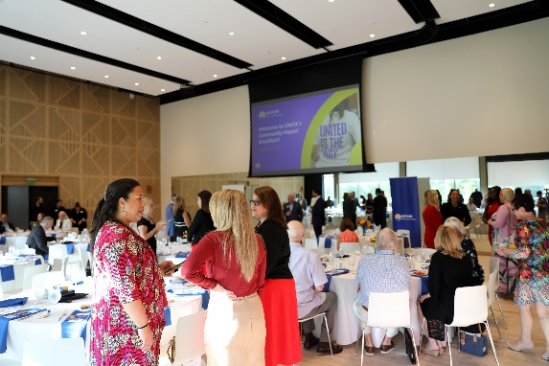
President and CEO Tiffani Mensch introduced volunteeruwck.org, Collier County’s new hub for volunteer opportunities. The platform allows organizations to create profiles and post opportunities, while individuals can find ways to get involved and make a difference.

Keynote speaker Carole Peters, representing United Way Next, inspired the room of about 100 attendees—including dignitaries, donors, and community leaders—to “Give, Advocate, Volunteer.” Peters invited the audience to stand if they or someone they knew had ever faced hardships or needed support. The response was powerful: every person stood, underscoring the vital role local nonprofits play in supporting the community.

This year, with Giving Tuesday on December 3rd and end-of-year giving on the horizon, Peters emphasized the importance of donations to sustain and expand this work. To inspire giving, UWCK announced a $100,000 donation match pledged by Mrs. Ellen Vanderburg—doubling the impact of every dollar contributed.

Through its refreshed brand, United Way continues to lead efforts that strengthen our community, inspire action, and create hope. To learn more about UWCK or to donate, visit their website and join in creating a stronger, more resilient future.

