**Media Contact:**

Alissa Hudak

[Alissa.hudak@uwcollierkeys.org](mailto:Alissa.hudak@uwcollierkeys.org)

724-710-1199

**FOR IMMEDIATE RELEASE:** November 6, 2024

**2024-2025 UWCK Marine Science Education Grant Recipients Announced**

**Florida Keys –** United Way of Collier and the Keys (UWCK) is proud to announce the recipients of the 2024-2025 Marine Science Education Grants. This year, **16** schools and organizations will receive a total of **$35,264**, benefiting approximately **6,465** students with hands-on learning experiences focused on marine science and conservation.

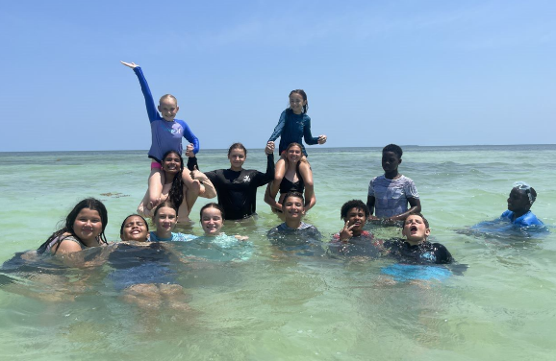Grant recipients: **Basilica School, CFK Academy, Coral Shores High School, Diving Museum, Gerald Adams Elementary, Key West Preschool Co-op, MarineLab, Mote Marine Lab, Ocean Studies Charter School, Poinciana Elementary, REEF, Reef Relief, Reef Renewal, Seacamp, Sigsbee Charter School (K-8th), and Sugarloaf School**

Now in its fourth year, the “Creating the Next Generation of Reef Stewards” grant program is part of a five-year UWCK commitment to invest $180,000 in marine education throughout the Keys. The initiative aims to foster environmental stewardship by providing students with opportunities to engage in marine science and conservation efforts.

“This program empowers students to connect with our marine environment on a deeper level,” said Jessica Dockery, UWCK Reef Revitalization Project Liaison. “By supporting these experiences, we’re helping to inspire the next generation of reef stewards—those who will protect and sustain our ecosystems for years to come.”

Poinciana Elementary School students (2023-2024 Grant Recipients) on a field trip.

One of the grant recipients, Gerald Adams Elementary, shared how the funding will impact their students: “This grant will allow our 5th-grade class to visit Dry Tortugas National Park by helping cover admission costs through the Yankee Freedom Ferry. It ensures that every student, regardless of financial circumstances, can participate in this once-in-a-lifetime experience.”

Through a partnership with the United Arab Emirates (UAE), UWCK is advancing reef restoration efforts while providing complementary education to ensure long-term sustainability.

For more information on Marine Science Education Grants, UWCK’s Marine Science Resource Guide, or upcoming scholarship opportunities, visit <https://uwcollierkeys.org/keysreefs/>.

**###**