Media Contact:
Alissa Hudak, Communications & Engagement Manager
Alissa.hudak@uwcollierkeys.org
724-710-1199

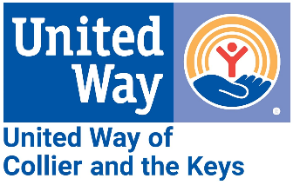
FOR IMMEDIATE RELEASE: October 26, 2023
2023-2024 UWCK Marine Science Education Grant Recipients Announced
Florida Keys – United Way of Collier and the Keys (UWCK) is excited to announce a new round of Marine Science Education Grant recipients. A total of $41,729 will be awarded to 17 recipients for 2023-2024.
Those recipients are as follows:
Basilica School, CFK Academy, Conservation Key, Coral Shores HS, I.CARE, Key West HS, MarineLab, May Sands Montessori School, Mote Marine Lab, Ocean Studies Charter School, Poinciana Elementary, REEF, Reef Relief, Reef Renewal, Seacamp, Sigsbee Charter School & Sugarloaf School
The series of “Creating the Next Generation of Reef Stewards” grants focuses on expanding opportunities and education for students in marine science and conservation. Currently in its third year, UWCK’s five-year commitment will provide $180,000 to schools and educational facilities throughout the Keys.
“These grants represent not only financial support but also a commitment to nurturing a deep love and understanding of our marine ecosystems,” said UWCK Reef Revitalization Project Liaison Jessica Dockery. “This year's recipients are poised to inspire the next generation of environmental stewards and carry forward the legacy of our beautiful marine ecosystems."
One of this year’s recipients, Conservation Key, explained how the grant would help. “Diving/snorkeling/boating can be financially inaccessible. Students can feel awkward or out of place without the right equipment,” said Marilu Cristina Flores, Founder & Chair. “Our workshops allow students to experience underwater exploration regardless of swim level (they do not get in the water, it is all conducted from the safety of a dock) or the ability to pay for training, equipment, or a transport vessel.”
Together with the United Arab Emirates (UAE), UWCK is investing in the future of local students through a bold initiative of reef restoration with complementary education to ensure sustainability. For more information on these efforts, including further details on the grants, UWCK’s Marine Science Resource Guide, and upcoming scholarship opportunities, visit KeysUnitedWay.org/ReefRestoration.

View our announcement video here.

###

