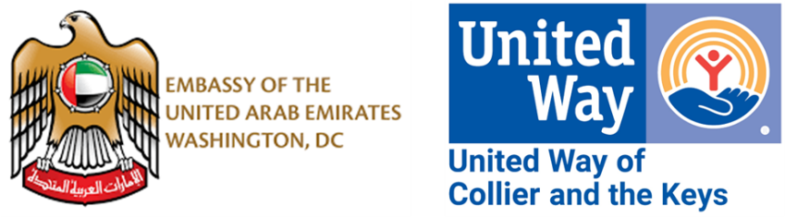
2024-2025 UWCK Marine Science Education Grant – Creating the
Next Generation of Reef Stewards
Complementing the reef restoration components of the UAE-UWCK partnership, education is critical to the sustainability of this bold project investing in the future of the Florida Keys. Our goal is that educating children to engage in stewardship and conservation from a young age will change habits and behaviors resulting in long-term success for the community and the inter-dependent ocean environment.
To begin to develop the program that would work best in Monroe County, UWCK conducted a survey of science educators to gauge marine science related interest, hurdles, availability, and programs already in place. UWCK then created the Marine Science Education Grant process below, crafted to give educators the flexibility to tailor their students’ experience thus maximizing impact. UWCK has committed $180,000 over 5 years to support these efforts.
Eligibility:
- Monroe County School District Schools
- Monroe County Licensed Childcare facilities and preschools
  - Materials/activities focused for ages 3 and up
  - Licensure will be verified through DCF
  - Limited to $500/year
  - All other criteria still apply
- Monroe County based marine science nonprofit (501c3) education centers or organizations
  - Program/expense must primarily benefit Monroe County children
Purpose:
Grants should be used to purchase, provide, or facilitate curriculum; materials and supplies; experiences; activities or field trips; or opportunities enhancing marine science education for Monroe County children ages 3-18.
Eligible uses may include transportation, substitute teachers, admission to facilities, curriculum and related materials, consumable supplies, trainings and conferences, equipment, food, student supplies and other directly related program specific expenses incurred to make this enhanced marine science programming possible.
Max funding available:
Up to $2,500 per school/organization or $500 per childcare facility per school year.
Engagement from schools/organizations:
- Educators apply via UWCK’s application between August 1 – September 30th, 2024.
- Educators/schools may submit 1 request per year.
- A goal of this program is to encourage community engagement. As such, a 1:1 match of funds is required. In-kind or creative solutions equivalent to your grant request amount are accepted.
  - In-kind examples include but are not limited to: donation of facility or boat usage, separately funded activity-related equipment or supplies, scientific equipment, expenses for transportation, substitute teacher costs, and food or other consumables.
- All applications must be approved by the Principal/Executive Director. Applications should be coordinated within a school’s staff if necessary.
- MCSD applicants must confirm their application fits within benchmarks listed in course description and conforms with district safety and educational processes. To go to the course descriptions, type or copy and paste the following URL into your browser. https://drive.google.com/drive/folders/1B5XJ-9xiYaFiD52tFq4Rn-l-CdFQPMI3?usp=sharing
  - It is the applicants’ responsibility to ensure any district, school, or student forms have been filed and approved with school administration.
  - For MCSD, lunch arrangements can be made through cafeteria services for bagged student lunches- please provide the cafeteria manager with a list of students.

Funding Process:
- Applications are submitted to and processed by UWCK staff through the online Google form.
- All applications are reviewed by an independent committee of UWCK staff and volunteer board, educators, marine science experts, financial experts, and community leaders.
Timing:
- This program supports 5 school years: 21-22, 22-23, 23-24, 24-25 and 25-26.
- Annual application period is August 1-September 30.
- Decisions are made in October and funding will be disbursed by November 15.
  - For MCSD, funds to be deposited into teacher’s internal account.
- Funds must be used by October 31 of the following year.
  - Schools and organizations must return significant outstanding funds to UWCK.
- Reports must be submitted within 30 days of field trip or resource purchase. No further applications will be accepted until funds are spent, and previous reporting is submitted and approved.
Application Requirements:
- Brief synopsis of project and how it enhances students’ education.
- 2 concrete deliverables, ideally with pre- data to support.
- Establish connection to UWCK-UAE marine science goals.
- Demonstrate proof of match (written, no photos).
- Upload budget of how funds will be utilized.
Reporting Requirements:
- Photos, video and/or written documentation from students demonstrating the project’s success.
- Accounting of how all funds were utilized.
  - Upload copies of expense receipts over $1,000
- 2 concrete deliverables, ideally with post- data to support.
- Number of Monroe County children engaged.
- Description of funded activity or purchase and how it enhanced student’s marine science educational opportunities.
Support Opportunities:
- https://uwcollierkeys.org/mseg/ has information specifically for educators interested in applying for this opportunity.
- For information on United Way’s marine science education related activities, contact UWCK Reef Revitalization Project Liaison, Jessica Dockery, at Jessica.Dockery@UWCollierKeys.org.

To find out more about UWCK’s broader reef restoration and education initiative, visit https://uwcollierkeys.org/keysreefs/ UWCK is excited to be a partner in creating the Next Generation of Reef Stewards for the future of our community.

