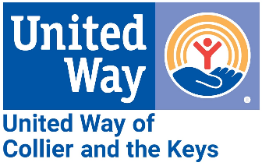
Media Contact:
Alissa Hudak, Communications & Engagement Manager
Alissa.hudak@uwcollierkeys.org
724-710-1199

FOR IMMEDIATE RELEASE: June 10, 2024
UWCK and UAE Announce Learning Exchange Program

Florida Keys – The United Way of Collier and the Keys (UWCK) and the Embassy of the United Arab Emirates (UAE) in the United States are excited to announce the launch of a new learning exchange program that will connect reef restoration professionals from the UAE and US. Set to begin in February 2025, the program will enable experts from both countries to share best practices and collaborate on solutions to common conservation challenges.
During visits to the UAE and US, participants will explore various locations for field-based projects and spend time learning from each other through presentations of their respective work. In addition to technical cooperation, the exchange will foster cultural learning and mutual understanding.
Dana Al Marashi, Head of Cultural Diplomacy at the Embassy of the United Arab Emirates in Washington, DC, emphasized the program's significance: “This exchange program deepens our longstanding partnership with United Way and US conservationists to protect the environment. With similar climates and marine ecosystems, the UAE and Florida Keys face many common challenges when it comes to reef preservation. By bringing together experts to share ideas, knowledge and resources, this exciting new program will contribute to a more sustainable future in both countries.”
Leah Stockton, UWCK Keys Area President, shared her enthusiasm, stating, “This program enhances our sense of community beyond our local area, uniting us in our efforts to save the reefs.”
UWCK President and CEO Tiffani Mensch added, “I am eager to see the progress we will achieve through this next phase. This program will demonstrate our journey and highlight the ongoing work required to sustain our efforts.”
The new program builds on the success of the "Revitalizing the Florida Keys through Reef Restoration and Beyond" initiative, which began in early 2020 with support from the UAE. The initiative has funded reef restoration efforts in collaboration with local non-profits, in addition to supporting Marine Science Educational Advancement Scholarships, Marine Science Education Grants, and more.
UWCK will provide updates on the exchange program as it develops, including the selection of participants this fall. For more information about the UWCK/UAE partnership and to view highlights from the recent UAE visit to the Florida Keys, click here.
###

