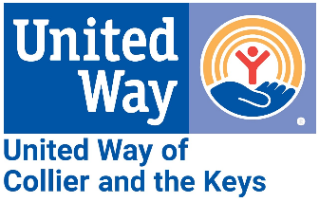
Media Contact:
Alissa Hudak, Communications & Engagement Manager
Alissa.hudak@uwcollierkeys.org
724-710-1199

FOR IMMEDIATE RELEASE: April 30, 2024
UWCK Celebrates Another Successful Tax Season Serving our Community
Volunteer Income Tax Assistance (VITA) Program Saves Taxpayers Over $134,000

Collier and Monroe Counties – United Way of Collier and the Keys (UWCK) proudly announces the successful conclusion of its Volunteer Income Tax Assistance Program (VITA) for the season, marking another year of impactful service to the community. UWCK extends sincere thanks to its dedicated team of volunteers and staff whose commitment made this achievement possible.
The VITA program, a cornerstone initiative of UWCK, helps lower-income community members, ensuring they can file their taxes accurately and at no cost. This season marked another triumph for the program, as nearly 500 taxpayers collectively saved an impressive $134,200, based on an average tax preparation fee of $275.
31 devoted volunteers generously contributed 2,740 hours of service at multiple sites across Naples, Key West, Marathon, Key Largo, and Islamorada. “Our team’s dedication and passion shine brightly, echoing our shared commitment to making a meaningful difference in the lives of others,” stated Loretta Geotis, VITA Coordinator.
UWCK President and CEO Tiffani Mensch praised the efforts of volunteers and staff, highlighting the organization's dedication to helping others. "The accomplishments of our VITA program underscore our commitment to helping those in our community achieve financial stability," said Mensch. "We are proud to celebrate another tax season of making a positive impact through this vital initiative."
For more information about United Way of Collier and the Keys and its initiatives, please visit www.uwcolliercollierkeys.org.

To download pictures from this tax season, click here.

###

