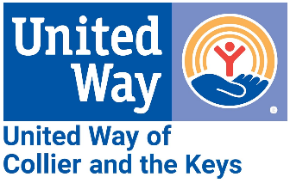
Media Contact:
Alissa Hudak, Communications & Engagement Manager
Alissa.hudak@uwcollierkeys.org
724-710-1199

FOR IMMEDIATE RELEASE: March 15, 2024
Publix Supports UWCK to Strengthen Our Communities
United Way of Collier and the Keys (UWCK) is deeply grateful to Publix for another extraordinary workplace campaign. We are thrilled to announce that Publix employees rallied together, raising an impressive $565,307.42 during the 2023 campaign – a significant leap from the $404,351.50 raised in 2022. But that's not all! In addition to the remarkable fundraising total, Publix employees showcased their commitment to community like never before, with participation surging to an outstanding 64% in 2023.
From March 11 – 15, UWCK employees thanked every Publix employee with visits to stores throughout Collier and Monroe Counties. Each visit was a reminder of the powerful community spirit that Publix fosters. You can find photos to share at the link below.
“The best part about the Publix campaign is that every dollar raised stays local to help people in our communities,” said Joe Paul, UWCK Board Member and Publix Manager.
Publix’s invaluable support empowers UWCK to serve 34 community partner agencies effectively. Among our diverse services stands the Volunteer Income Tax Assistance (VITA) program, offering individuals the opportunity to have their taxes prepared for free. To learn more about the ongoing VITA program, visit: uwcollierkeys.org/vita.
To Publix: UNITED, we're building brighter futures and fostering lasting change. Your steadfast partnership and commitment to our shared mission are pivotal in strengthening Collier County and the Keys. Thank you!
Download Publix Appreciation Week photos here.

###

