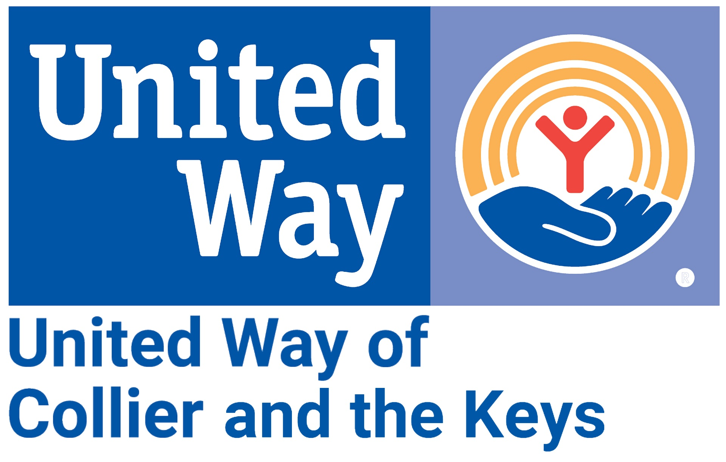
Media Contact:
Alissa Hudak | Alissa.hudak@uwcollierkeys.org
724-710-1199

FOR IMMEDIATE RELEASE: December 14, 2023
Appointments Now Open as United Way of Collier and the Keys Prepares for Tax Season
Volunteer Income Tax Assistance Program Helps Residents File for Free

As tax season nears, the United Way of Collier and the Keys' Volunteer Income Tax Assistance Program is preparing to help residents with 2023 household incomes under $66,000 file for FREE.
During the 2022-2023 Tax Year, the VITA program:
- Served 346 taxpayers.
- Generated nearly $250,000 in refunds.
- Saved over $100,000 in taxpayer prep fees (based on an avg. cost of $275/return).

We are delighted to offer this vital program once again to our community. UWCK’s commitment to assisting residents in navigating tax season remains unwavering.
Free tax preparation services are provided by IRS-certified volunteer tax preparers, and volunteers are still needed in Key West.
If you are interested in learning more, please contact vita@uwcollierkeys.org.

Appointments are necessary in Collier County, while they are not required in Monroe County.
Collier County: Every Wednesday; 1/24/24 - 4/10/24; 9am - 3pm; 9015 Strada Stell Ct #204, Naples
Monroe County:
KEY WEST: Every Wednesday; 1/24/24 - 4/10/24; 10am - 2pm; Gato Building - 1100 Simonton St
2/22/24; 4pm - 8pm; Bernstein Park - Corner of 5th St & 5th Ave
MARATHON: Every Thursday; 1/25/24 - 4/11/24; 12:30pm - 4:30pm; Marathon Library - 3490
Overseas Hwy; *9am - 12pm on 2/8/24

For details on scheduling an appointment, understanding appointment requirements, or assisting us in spreading the word, please download and share the attached flyers corresponding to each county.
Collier County flyer; Monroe County flyer

For media outlets, we are pleased to offer photos and interviews for you to use on air/in your publications.
Download; Interview information

